Pécs2010 - European Capital of Culture

AFTER THE CULTURAL CITY

New Positions for Culture in Urban Development
International Conference,
Pécs, 2010. September 24-25.

In the course of the post-industrial transformation of Western societies, culture became a definitive element in urban development. By the end of the 1990s, culture-led planning became a framework dominating urban strategies of First World cities. The concept of culture-led urban development suggests that the extension of cultural infrastructures, institutions and programs in cities leads to improvements in social integration and quality of life, invites new industries, creates jobs and attracts trained workforce and consumer tourism.

New notions rooted in the discourse of culture-led planning such as the Bilbao-effect, the Creative City or the Festival City spread quickly across North American and European cities and influenced development policies through the practices of architects, sociologists and policy makers. While the new development paradigm placed a previously unknown emphasis on so-called soft, social and anthropological elements of urban development, the results of such programs divided professional reflections which often strongly criticized cultural development projects for their gentrification effects, social engineering ambitions and unsustainable evolution patterns.

Since the Hungarian city of Pécs won the title of European Cultural Capital and thus entered the EU's culture-led urban development framework, profound transformations have been taking place both in the city and its global context. The global financial crisis and the resulting recessions of the last two years have significantly upset the basic concepts of post-industrial urban development, which previously had seen cultural industries as pivotal channels through which economic growth based on speculative real estate developments could be brought back into the city.

Culture-led development policies need to be revisited not only because their economic bases have faded away, but because the profound differences in urban scales as well as geographical, geopolitical contexts have so far largely been ignored in their implementations. In the belated post-industrial transformation of Eastern and Central Europe, culture-led urban development and the ECoC program appeared as a promising alternative to urban regeneration conceived exclusively as an ensemble of isolated development projects undertaken by private investors. The mechanical adaptation of Western cultural patterns was impeded by a number of factors: the underdeveloped cultural infrastructures, the insufficiencies of education and of the access to resources, the separateness of architectural, cultural and management ventures, and the economic crisis that hit the region hard forced East-Central European cities to rethink their strategies.

Besides the economic models, urban systems related to the notion of culture also need to be reconsidered. The goal of the ‘After the Cultural City’ conference is to rethink the possibilities of culture-led urban development in the post-crisis economic, political and social climate, to assess its limits, its remaining and new relevant targets in Central and South East Europe and to outline new possible ways of development for Pécs and other cities in the region. Our intention is to present research and critical approaches as well as methods and best practices that invite strategic collaboration between scholars, policy professionals, decision makers and designers. The conference, inviting internationally known theorists, policy makers, sociologists, art and architectural historians, cultural activists and practicing architects and urban planners, is organized around questions related to the international transfer of concepts and policies, the legacy of the Creative City after the economic crisis, the relationship of infrastructures and new technologies to the access to culture, and the role of cultural innovation in regenerating peripheral neighbourhoods and regions.

Confirmed keynote speakers:
Franco Bianchini, Juan Herreros and Saskia Sassen.

Invited lecturers include:
Matej Bejenaru, Bodó Balázs, Bryan Boyer, Fabien Girardin, Adam Greenfield, Bas van Heur, Sabine Knierbein, Bert van Meggelen, Fabrice Raffin, Dominique Rouillard, Richard Russell, Nada Svob-Dokic, Jakub Szczesny, Kai Vöckler.

Conference Sections
1. Travelling concepts, cultural transfers, different scales
The majority of European cities are not metropolitan, neither in their scale nor in their connectedness. The continent's network of cities and towns is in constant transformation, due to the EU integration process: regions emerge and evaporate, as political and economic borders of nation-states blur. The economic role and competitiveness of culture is thus very different at the peripheries of Europe than in the Anglo-Saxon world, for instance. However, urban policy makers in the previous years have increasingly referred to concepts embedded in the economic, political and social realities of the developed world.

The European Capital of Culture project is a particular European initiative that gives the opportunity to various cities every year to gain momentum for their development with the help of subsidized new art institutions, as well as increased cultural consumption and augmented visibility generated by them. The ECoC program, while offering space and channels for the dissemination of the concepts of culture-led urban development, may also serve as an experiment to examine the impregnation of these concepts in contrasting economic, political and social contexts.

The section aims to investigate the following questions: What are the conditions that make culture-led urban development work in different relational and urban structures? In what ways are cultural events, strategies and concepts transferable between different contexts? What is the role of cultural translation in localizing global experiences? How to learn locally from international ‘best practices’?

2. The Creative City and the crisis
After the departure of industrial production in the developed countries, the engine of the past two decades' urban developments was the real estate market; spectacular architectural investments, including new museum and concert hall infrastructures functioned as catalyzes of this market, lately legitimized by the Creative City concept. Since urban space entered the speculative milieu of global financial markets, the speed, dynamics and risks inevitably backlashes to the physical, architectural environment.
Architecture has played a central role in the Creative City, but with the weakening of the global real-estate market and the abandonment of large-scale development projects, architects and designers are among the professionals who face the challenge to reconsider their position in urban development. While Europe has too few states that could effectively intervene to restore processes of the urban economy, consumption and construction, certain municipalities addressed the problems of the changing urban landscape (vanishing jobs, empty storefronts and worsening living conditions) with innovative policy initiatives helping unfold social entrepreneurialism and organizational capacities.

This section seeks to interrogate the following issues: What is the role of cultural organizers, architects, designers and municipalities in addressing living conditions in today’s cities? What are the new professional models developed by architects and designers? How do cultural initiatives find funding in the current economic conditions? What are the perspectives of the Creative City concept in the aftermath of the economic crisis?

3. Infrastructure, technology and urban culture
During the deregulation phases of urban development the significance of urban infrastructure has seriously diminished, only to come back into the focus of attention of many professions in recent years. The cultural significance of physical infrastructures lies not only in the roles they play as the utilitarian background of urban daily life, but rather in the huge long term influence they have on the urban environment by their visibility, appearance and way of functioning. These systems, previously typically inaccessible and closed from the public, are becoming the new urban agorae, open zones whose services are understood not only as ready-made products but rather as platforms where new discourses and new exchanges in and of the city are taking place.

The exploding technological progress of the last two decades – unfolding parallel to the deregulation and globalization of financial and real estate markets – has also profoundly transformed the relationship of the urban environment and its inhabitants. The entry barriers of using advanced technologies have dropped enormously while highly complex sets of real time information and other data about the city's urban spaces, infrastructures and institutions are becoming accessible to the general public. Beyond the personal environments of work and dwelling, physical built space and technology do not exist anymore as parallel universes but instead as intertwined, symbiotic, augmented realities that define the ways culture is consumed and used in the everyday.

The section is organized around questions of access to networks and infrastructures: What are the challenges that municipalities face in reconsidering infrastructure in the light of new technologies? How can new technologies open new access to culture? How can cultural infrastructures in cities be connected to networks of information and knowledge distribution? How can cultural and information infrastructures enhance the use of and access to urban public space? How does the tendency to decentralize cultural institutions and to outsource cultural functions to non-profit organizations affect the relationship between municipal governments and the civic sphere? What are the policy elements of developing the ‘open source city’?

4. Innovation at the peripheries
While in previous years the centre-periphery relationships have been significantly reorganized in the contexts of both urban agglomerations and national economies, peripheral neighbourhoods of large agglomerations and marginal regions were forced to experiment with strategies that may avoid dependence on the centres’’ economic, cultural and technological capital. These communities have become laboratories of social, economic and cultural innovation. The problems of peripheries are not only geographical but also technological, which raises the question of innovation options and policy limits in developing regions.

This section raises questions focusing on the development potential of culture in marginal places: How can peripheral neighbourhoods and regions, and marginal communities reposition themselves in the emerging regional and global cultural and technological networks? What is the role of Western institutions in catalyzing local capacities by cultural initiatives? What is the role of bottom-up cultural initiatives and culture-led planning at the peripheries and in small cities? How can culture and access to information networks become an asset in the development of disadvantaged cities?

5. Perspectives and new strategies
By investigating the changing relationship between cultural initiatives and infrastructures and the urban economy, the conference aims to outline new strategies of culture-led urban development. With the transformation of the economic background of cultural industries, urban development faces new challenges, bringing about a broadened notion of culture and giving an extended role to non-governmental actors in structuring access to culture.

The closing session of the conference will turn analyses into anticipations, by addressing the following issues: Can culture become once again a catalyzing force? What might be the new context of culture and how can it be tackled by economic, policy and management models? Who is able to finance today's cultural developments? How can culture become once again a catalyzing force? What are its perspectives and what are the areas it has lost? What are the main dilemmas related to culture-led planning at the beginning of the 2010s?

Organization & Contact
The conference is part of the Architecture and Context program, a collaboration between the South-Transdanubian Chamber of Architects and the Mihály Pollack Faculty of Architecture and Urbanism at the Pécs University on the occasion of the city’s European Capital of Culture title year. For further inquiries please contact:

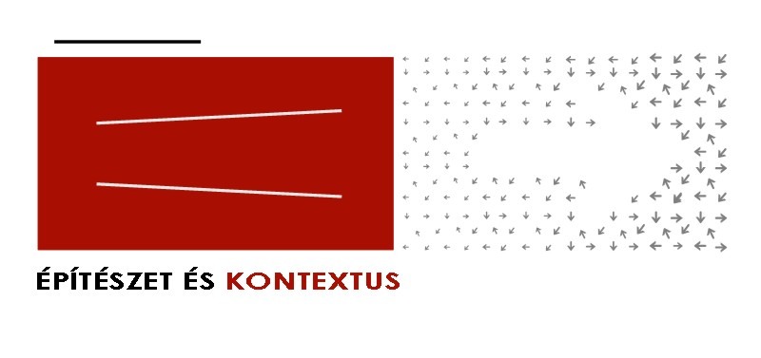

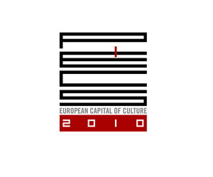


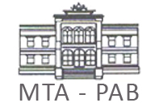
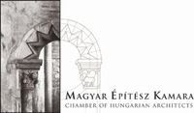

More information
- www.ek2010.hu

Responsible for thematic:
- Levente Polyák (levente.polyak@kek.org.hu, +36 30 4359002)
- Samu Szemerey (samu.szemerey@gmail.com, +36 20 347 2046)

Partners:
- South-Transdanubian Chamber of Architects
- Zoltán Bencze, architect (general thematic leader)
- Mihály Pollack Faculty of Technology, University of Pécs
- Department of Communication and Media Sciences, University of Pécs
- Association of Hungarian Urbanists

Sponsors:
- Pécs2010 Menedzsmentközpont Nonprofit Kft.
- Hungarofest Nonprofit Kft.
- Hungarian Chamber of Architects
- Hungarian Association of Architects

